

**User Research Outcomes**

**LAB SHEET 4**

**M.P.P.Shamil | IT17018760 | SE3050 - UEE**

* + 1. **nura**

# Responsibilit: ies

* + - * **Usually take care of the patients who got appointment for me**
      * **Keep track of the appoin. tment of the patients**
      * **Keep track of the available time of the doctor.**

# Goal:s

* + - * **Store Appointments and free dates.**
      * **Easier way to view appointments**

.

### Profile Attributes

Age:49

Location:Athurugiriya,Sri Lanka Occupation:Doctor(MBBS |MBA) Working at:National Hospital,Homagama

**Pain Point:s**

##### Hard to find the way to added appointment on the.

* + - * **Hard to edit events on the list without labe**.**ls**
      * **Color theme is notcomfortable**.

**list**

**Tech**

Mobile Applications

##### Wants to view available dates and holidays of the months

Internet

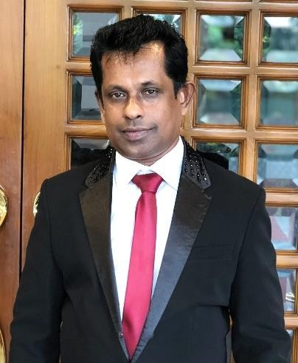

## Emotions and attitud: es

##### Mostly looking for a attractive designes.

* + - * **Likes to try new interface applications.**
      * **Mostly unfamiliarwith new technologies.**
      * **Likes plain and simple interface colors**

Write Documents

Social Media

M.P.P.Shamil | IT17018760



# Task 2:User Stories

* + - * + As a doctor I want add appointment details of the patients
        + As a doctor I want to view my added appointments of the patients
        + As a doctor I want to edit those added appointment details
        + As a doctor I want to edit appointment dates
        + As a doctor I want to delete added appointments
        + As a doctor I want to view sorted appointment as a date





Access Home Screen

Goes to Calendar

Add an appointment

View Appointmet

Doctor

Access Home Screen

Doctor

Goes to calendar

page

Search for a appointment

page

Edit appointment details